**Obi Chioma Blesing**

[**Obi.chioma@womentechsters.org**](mailto:Obi.chioma@womentechsters.org)

**WT/21/173**

**Practical Activity 5**

Assuming you are a system administrator in “CarMax” Car Dealership and you have been assigned with a task to add 1 Headquarters and 2 Sales Locations in a windows Server 2016 you configured.

1. With the help of Active Directory, Add the Headquarters and 2 Sales Locations.

**Headquarters has:**

* Administrative Dept
* Accounting Dept
* Hr

**Each Sales Location has:**

* Sales Staff
* Mechanic Staff
* Management

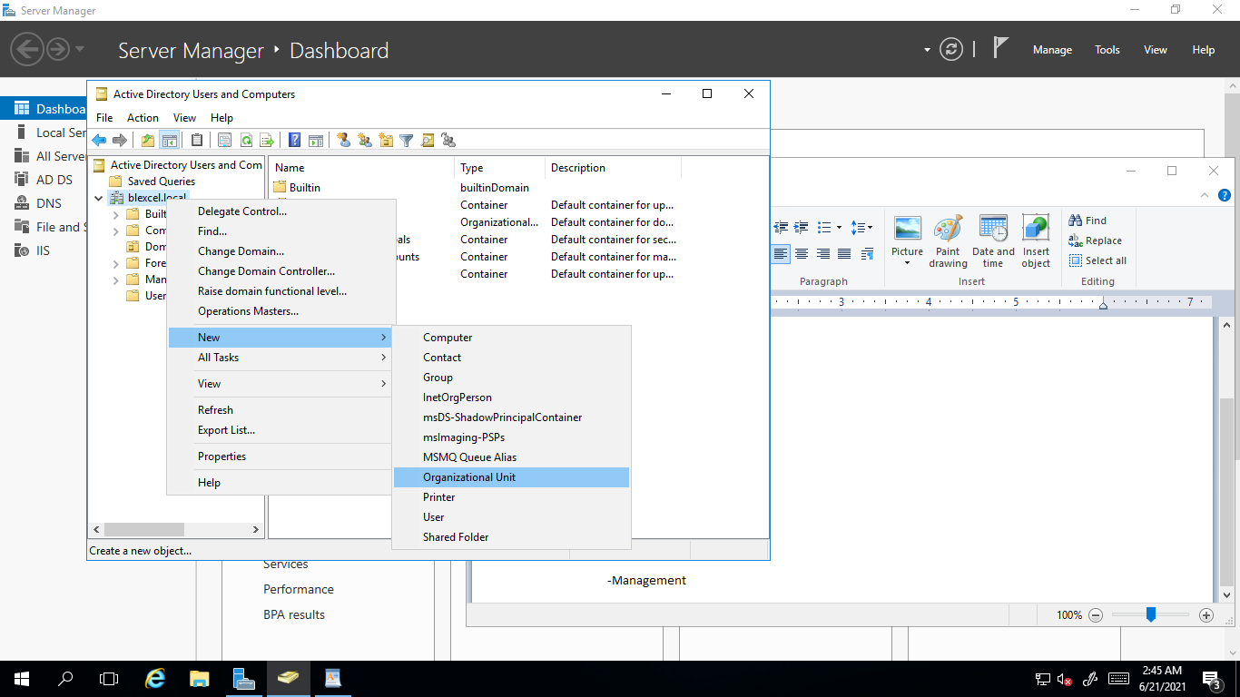

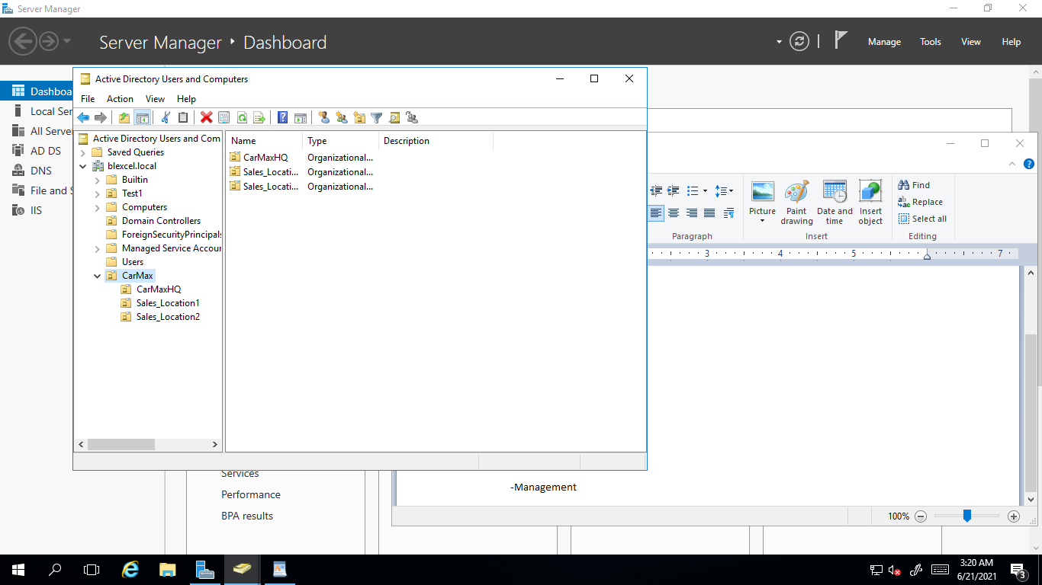

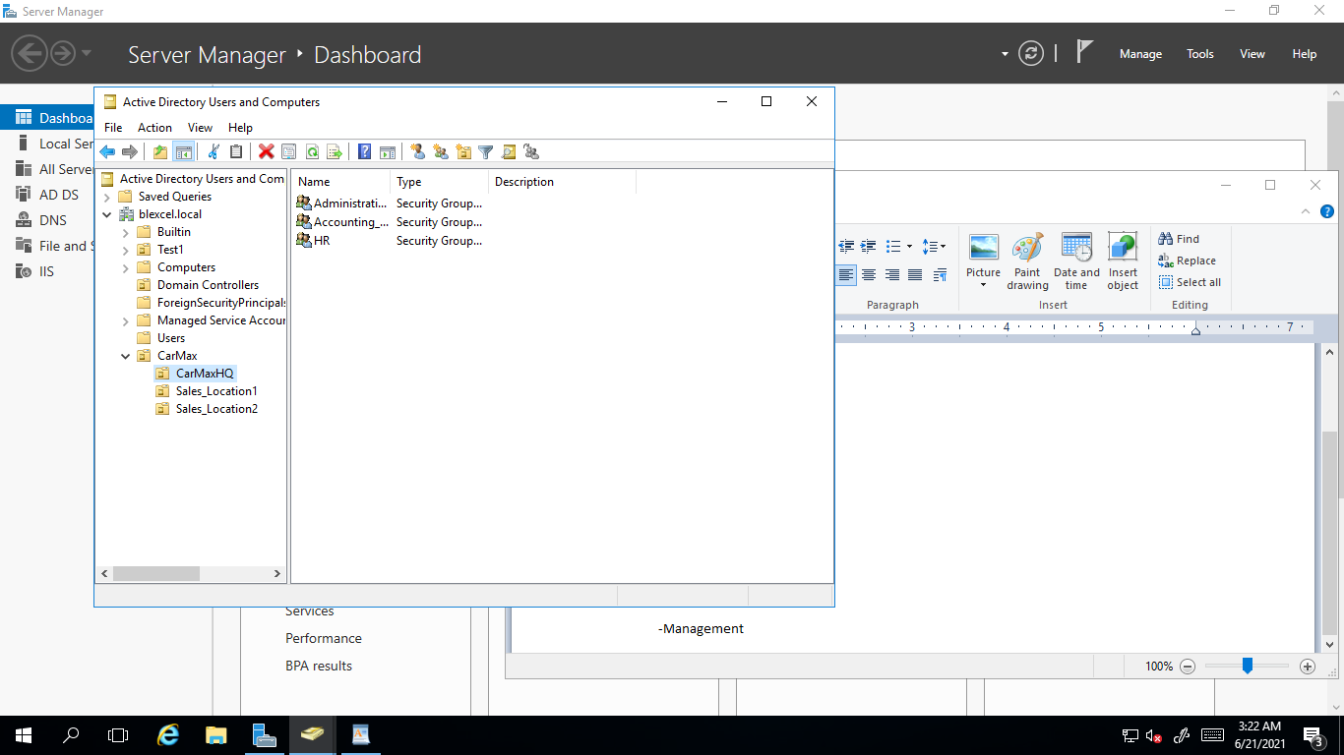

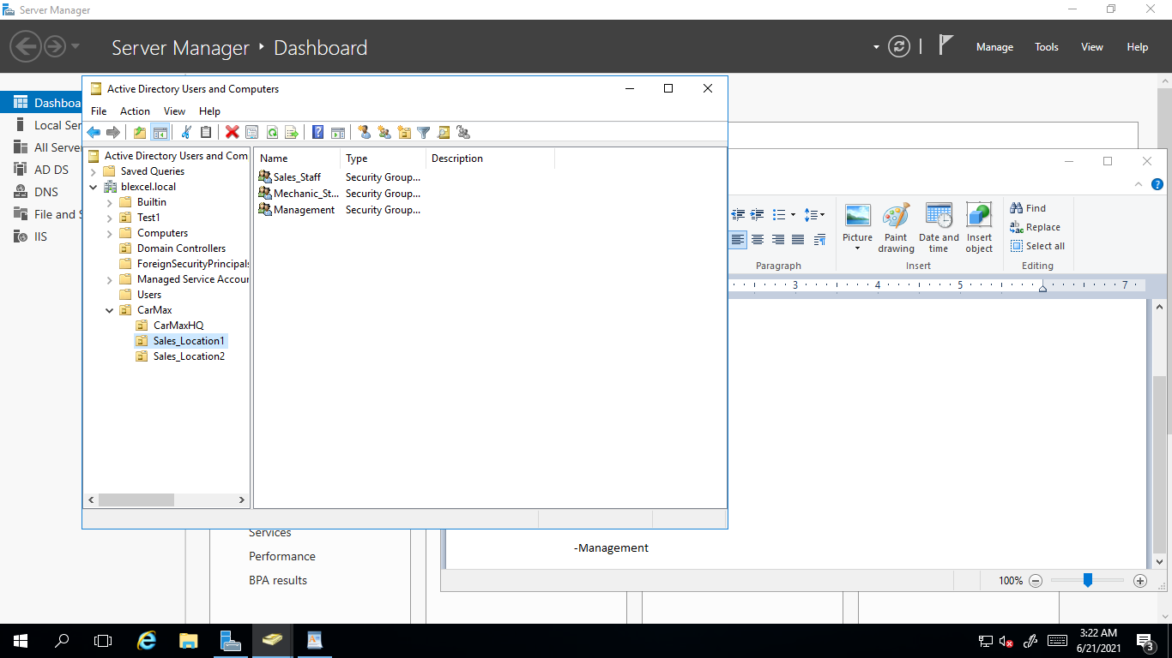

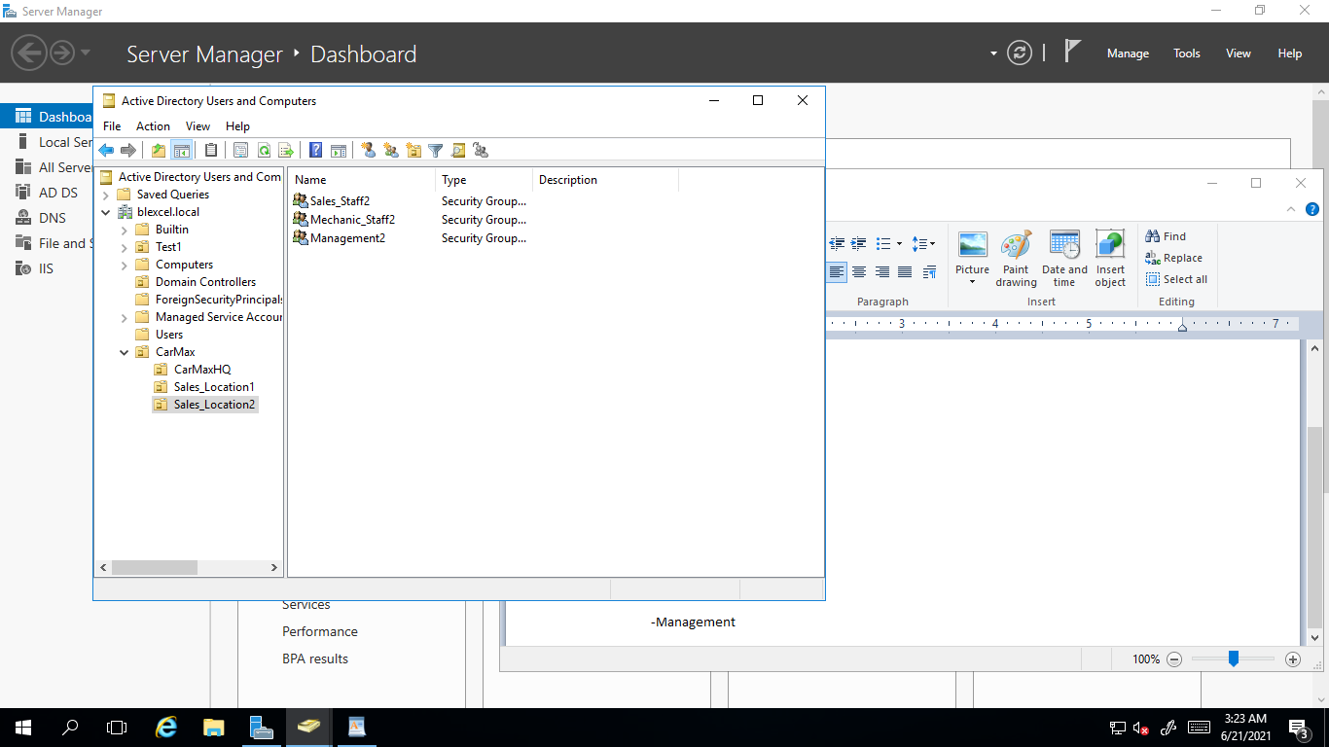

1. **Under each Unit add dummy users.**

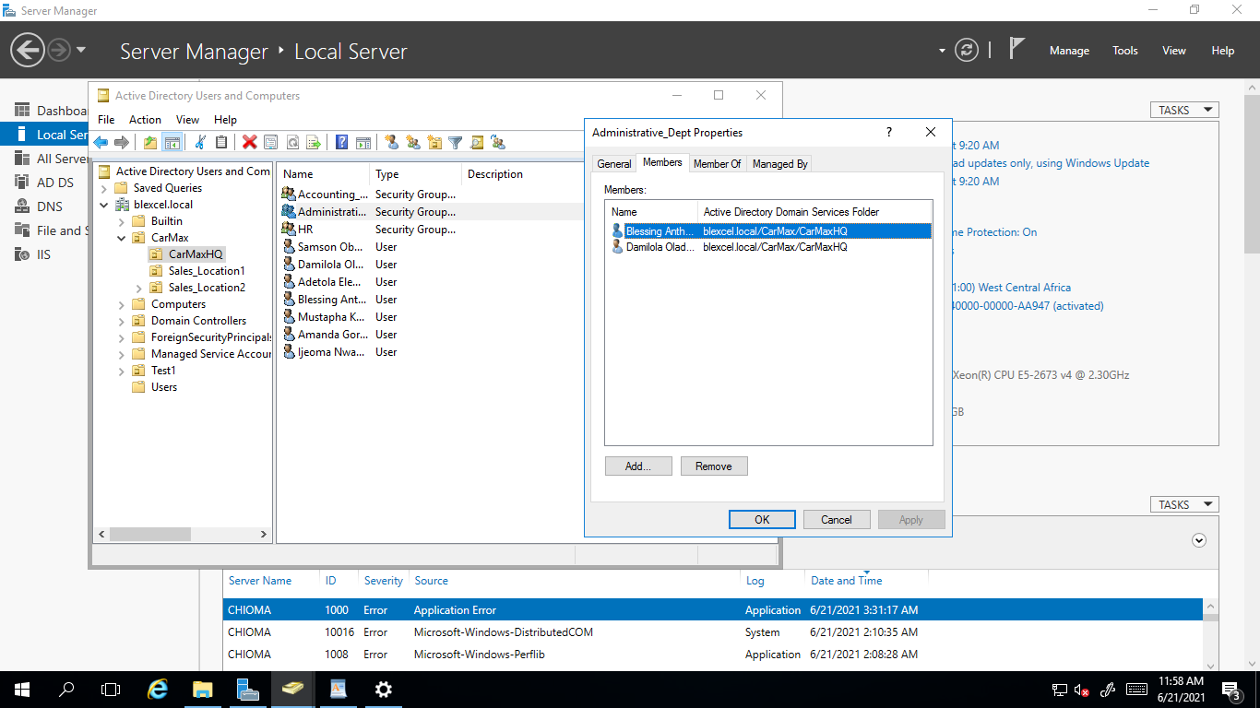

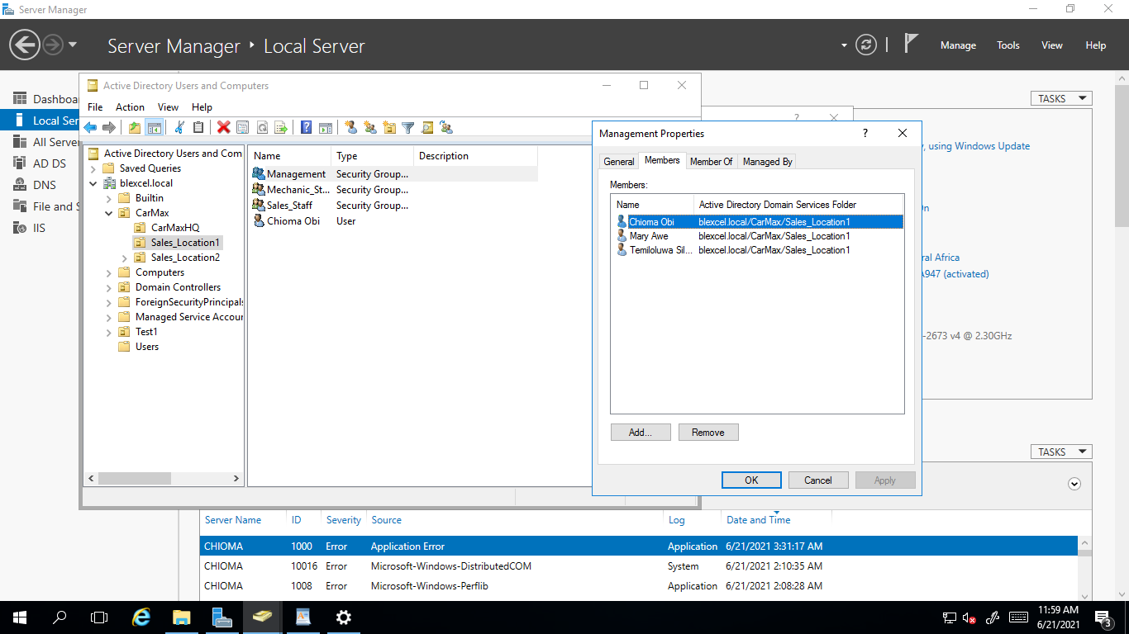

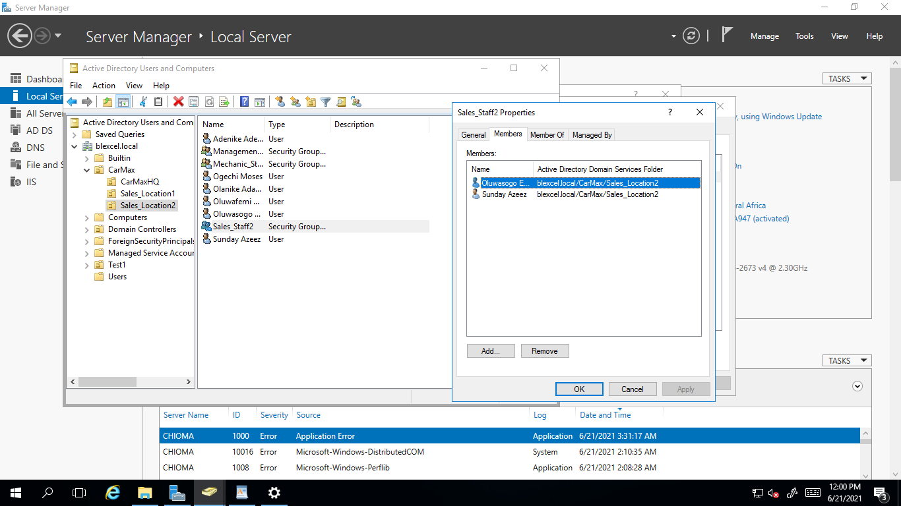

1. Assuming a user in Sales Staff is promoted to Administrative Dept, give a description on how you will handle this and make sure the **sales user is effectively transitioned to Administrative Unit**. Please give a detailed description with accompanied screenshots.

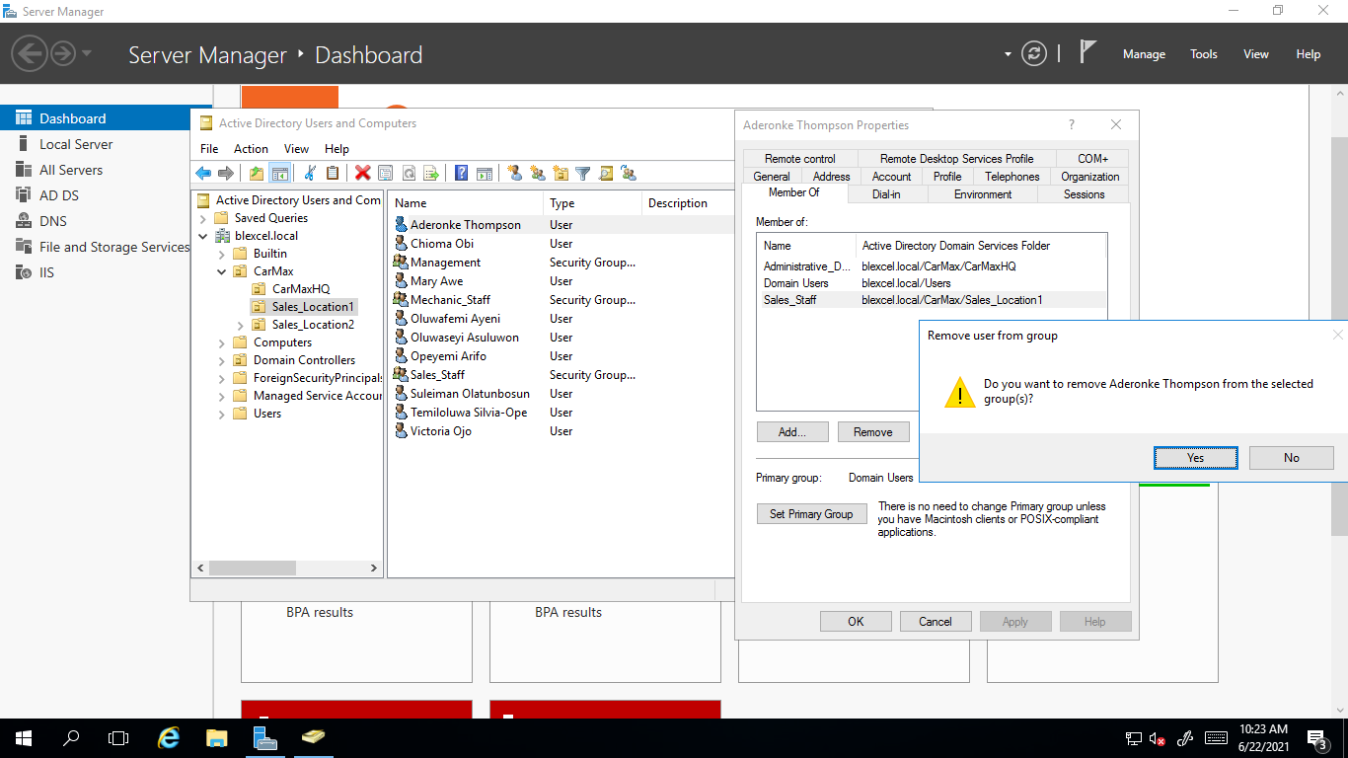

1. Assuming “One dummy” user in Mechanic Staff has gone on leave for one month, give a detailed description of how you will ensure **their user account is inactive and cannot be accessed by any other person during this one-month leave.** This is to ensure unauthorized users to do not use that account to access the organization system.

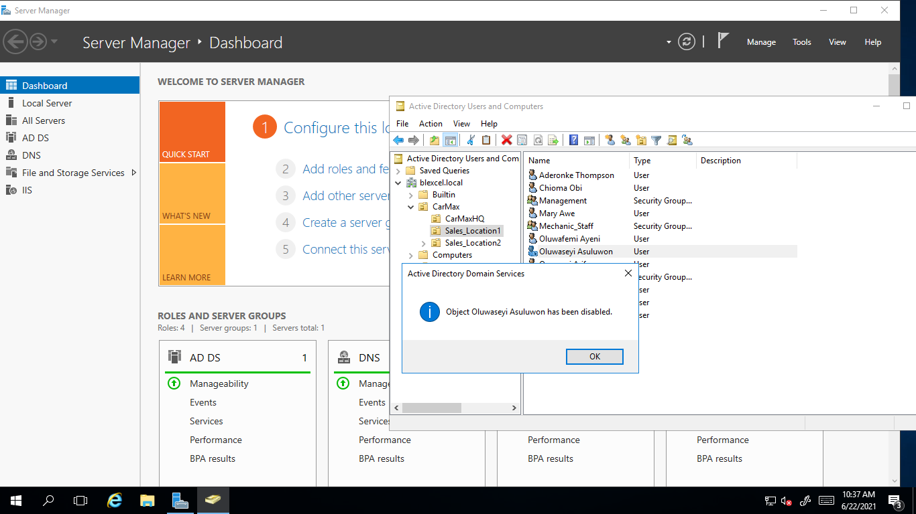

1. In accounting Dept, we want to maintain high notes of security especially to the computers. **Add a computer policy under Accounting Dept** to ensure all computers are locked or disabled after 3 minutes of inactivity. The user has to login once again when back.

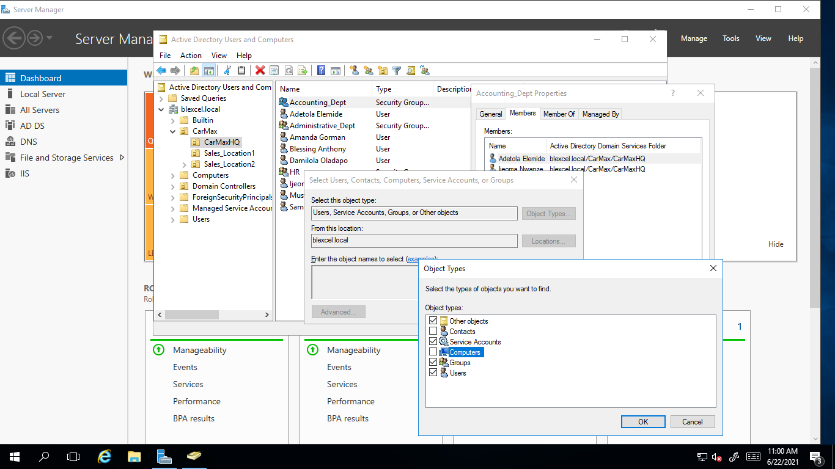

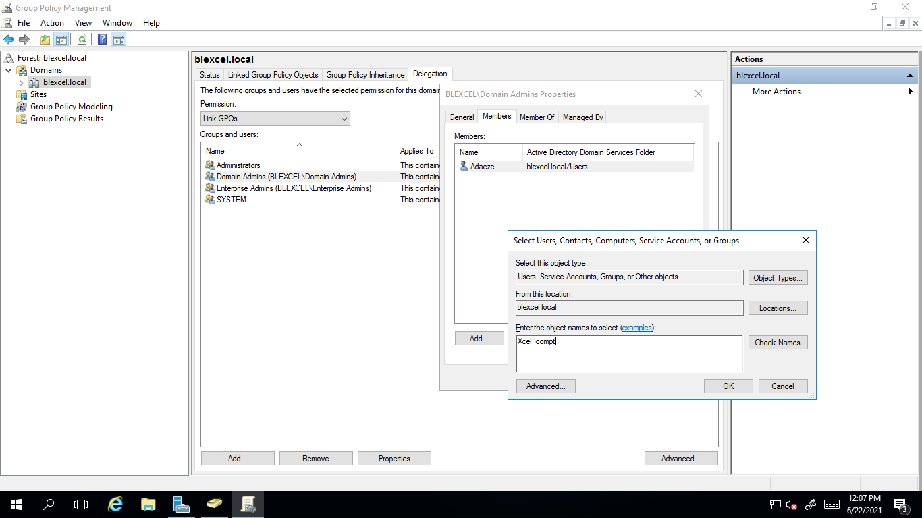

**All these steps and procedures should be well documented with explanations and accompanied with screenshots.**